**Sister Assumption Paschalia**

**Superior General**

**ASSUMPTION SISTERS OF ELDORET**

**P.O.Box 191-30106, Turbo**

**Kenya**

**RE: NYAATHA EDUCATION ENDOWMENT FUND (N.E.E.F.)**

Dear Sister

As you are aware, in July 2015, Sr. Angela Adhiambo A.S.E., has been inspired to create a trust fund by the name Nyaatha Education Endowment Fund (N.E.E.F.). This Fund aims to provide scholarships for the post-primary educational needs of the disadvantaged children transitioning from rehabilitation centres and girl at risk.

The name of the Fund was in given after the Blessed Sr. Irene Stefani, a member of your congregation. This name is famous has it was given because of her charitable work among the poor, the afflicted and the sick that she served with a smile in the early 1900s. She became a Ray of Hope for them, and Nyaatha Education Endowment Fund aim to continue her work.

Therefore Sister Angela, with the help of a volunteer, decided to formally establish the Nyaatha Education Endowment Fund with the following vision, mission, values and goals:

**Vision:** Instilling hope in disadvantaged children in the footsteps of blessed Irene Stefani

**Mission:** To provide for the post-primary education needs of:

1. Disadvantaged children transitioning from rehabilitation centres
2. Children from disparate backgrounds
3. Disadvantaged girls at risk

**Values:** The generosity that arises from compassion for underprivileged children, guided by integrity and fairness while exercising patience and fortitude.

**Goals:**

* To improve the sustainability of Nyaatha charity Organization.
* To foster Christian values and support the work of evangelization
* To promote integral education and on-going formation of young people
* To foster education status and welfare of the young people through the program
* To encourage self-reliance and support the holistic structure of young people.

**To give an identity to the Fund, the following logo was designed.**



Furthermore, the team decided to have the following structure.

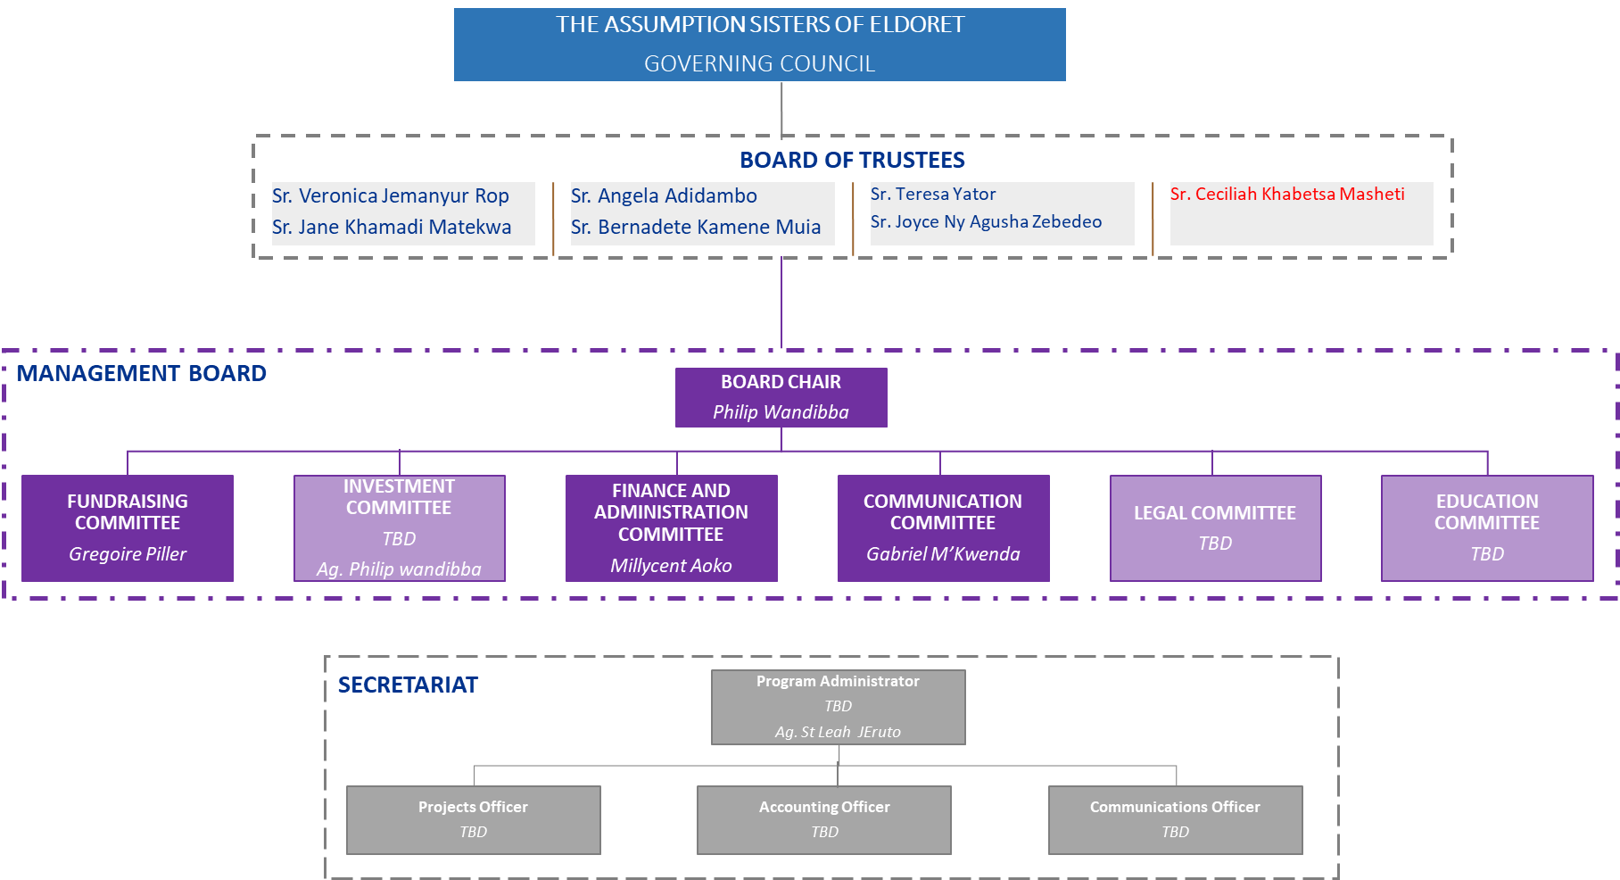

To fulfil the above structure, the team decided to nominate

**General Council**

The Assumption Sisters of Eldoret, Turbo, Kenya

**Board of Trustees**

1. Sister Angela Adhiambo - Chair of the Board of Trustees
2. Sister Veronica Jemanyur Rop
3. Sister Ceciliah Khabetsa Masheti
4. Sister Jane Khamadi Matekwa
5. Sister Teresa Yator

**Management Board**

1. Philip Wandibba – Chairman, in charge of Investment
2. Gregoire Piller – Vice-Chairman in charge of Fundraising
3. Millycent Aoko – Secretary in charge of Finance and Administration
4. Gabriel M. Kwenda – Member in charge of Communication

**Secretariat**

1. Sister Leah Ruto

**Who we serve:** Nyaatha Education Endowment Fund decided to help people living below the poverty line. They only get what is barely sufficient for their daily survival, which has contributed to the organization to go extra miles in also looking food for the children who are malnourished in the community. The organization move from one company/organizations to another searching for the support of food, shelter and finally education support, not only companies but also from good wishers.

**Target Groups** Most of the young people we meet both in church, on the streets and in the community are unable to meet their educational needs and personal effects. The majority of the populations we serve are small scale farmers and also people who affected by tribal clashes during post-election violence that contributed many children being left by their parents. Whose output cannot sustain the family as well as undertaking the caring? The need to reach these young people is so great.

**Nyaatha A Ray Of Hope:** The result of the Fund is to empower the disadvantaged children and give them a Ray of Hope through the education to be able to stand on their own and also become a ray of hope for others. Some of the young men who are now in colleges or joining colleges were street boys, and now they have a Ray of Hope because of the mercy shown to them by others through the support of their education. Here are some of the testimonies:

Since 2015, Nyaatha Education Endowment Fund has started some project.

**Farm projects:** This farming project has been made possible by the Assumption Sisters of Eldoret who have agreed to give part of their farm to Nyaatha Education Endowment Fund (N.E.E.F.) to use it for raising funds for supporting the children being sponsored. The farm is located in Kerio Valley in the Great Rift Valley. Some farming activities are already in place, and an orchard is being developed as can be seen in the photographs of some of the items that are being grown, such as watermelons, butternuts and pawpaws. Challenges of marketing are being explored to enable maximum benefits from the produce.

The farm intended to be a boot camp during the holidays. This will enable children to learn to farm and appreciate where some of the funds of their education come. Since one of the Economic Pillars of the Kenya government is agriculture, the exposure of the children may make some of them also to develop an interest in farming. It is, therefore, one of the ways of empowering them.

A management structure for taking care of the farm activities is being employed. Expertise is also being the making sure that maximum returns are realized from the farm, and this will also inform the number of staff needed. The photographs are showing what can be referred to as the first fruits.

Furthermore, Nyaatha Education Endowment Fund has opened a bank account.

**1. Bank Deposit/Transfer: A.B.C. Bank Account Number: 002234001000037**

and created a website [www.nyaathafunds.org](http://www.nyaathafunds.org)

Finally, Nyaatha Education Endowment Fund was registered on the following address:

A.S.E. – Nyaatha Education Endowment Fund

P.O. Box 7251-30100, Eldoret, Kenya

Telephone: +254 722 241 382

Email: [info@nyaathafunds.org](mailto:info@nyaathafunds.org)

Therefore, we are requesting by formally replying to this letter to for formally approve the above structure, logo and leadership and to ease the work of the management board to give the board power of attorney, to 1) take care of the accounts, financials, and investments 2) design and implement a comprehensive strategy 3) givenxxxxxxxxxxx

We are Looking forward